**LAMBDA**

**What are Lambdas Functions?**

AWS lambda are server-less compute functions are fully managed by the AWS where developers can run their code without worrying about servers. AWS lambda functions will allow you to run the code without provisioning or managing servers.

Once you upload the source code file into AWS lambda in the form of ZIP file then AWS lambda will automatically run the code without you provision the servers and also it will automatically scaling your functions up or down based on demand. AWS lambda are mostly used for the event-driven application for the data processing[Amazon S3 buckets](https://www.geeksforgeeks.org/introduction-to-aws-simple-storage-service-aws-s3/), or responding to HTTP requests.

**Example:**

1. Process data from Amazon S3 buckets.
2. Respond to HTTP requests.
3. Build serverless applications.

Imagine you have a piece of code that needs to run whenever something specific happens—like when someone visits a website, updates a database, or clicks a button in an app. AWS Lambda lets you do that without needing to set up or manage any servers.

Here’s how it works:

* You upload your code to AWS Lambda.
* Lambda waits for an event to trigger it—this could be things like a web request or a data change.
* When the event happens, Lambda runs your code automatically.
* It handles all the behind-the-scenes work, like scaling based on demand, keeping things secure, and making sure the code runs smoothly.

Some real-world examples of how AWS Lambda is used:

1. **Website Backend Operations** Imagine you have a website that lets users upload images. Whenever a new image is uploaded, AWS Lambda can automatically resize it and store multiple versions (e.g., thumbnail, high-resolution) without needing a dedicated server.
2. **Chatbot for Customer Support** Businesses often use chatbots to assist customers. When someone asks a question, AWS Lambda can analyze it, find a suitable answer, and reply instantly—all without running a separate chatbot server.
3. **Fraud Detection in Banking** Banks use AWS Lambda to detect fraudulent transactions. If a transaction seems suspicious (like an unusual purchase from another country), Lambda can immediately alert the customer or block the transaction.
4. **Automated Email Notifications** Suppose an e-commerce site wants to send a confirmation email when a user places an order. Lambda can trigger an email service to send the message without requiring extra infrastructure.
5. **SocialMedia Auto-Posting** If you manage a social media account, you could use AWS Lambda to automatically post updates whenever new content is added to a blog or database.

**Use Cases of AWS Lambda Functions**

You can trigger the lambda in so many ways some of which are mentioned below.

1. **File Processing:**AWS lambda can be triggered by using simple [storage services (S3)](https://www.geeksforgeeks.org/introduction-to-aws-simple-storage-service-aws-s3/). Whenever files are added to the S3 service Lambda data processing will be triggered.
2. **Web Applications:** You can combine both web applications and AWS lambda which will scale up and down automatically based on the incoming traffic.
3. **IoT (Internet of Things) applications:**You can trigger the AWS lambda based on certain conditions while processing the data from the device which are connected to the IOT applications. It will analyze the data which are received from the IOT application.
4. **Stream Processing:** Lambda functions can be integrated with the Amazon kinesis to process real-time streaming data for application tracking, log filtering, and so on.

**Lambda Function Anatomy:**

**Handler function:** Function to be executed upon invocation and it requires two arguments “event” and “context”.s

**Event Object:**Data send during lambda function invocation.

**Context Object:** This is generated by the platform and contains information about the underlying infrastructure and execution environment such as allowed runtime and memory**.**

**Lab Steps**

Task 1: Sign in to AWS Management Console

1. Click on the Open Console button, and you will get redirected to AWS Console in a new browser tab.

2. On the AWS sign-in page,

· Leave the Account ID as default

·Now enter your username and password.

3. click on sign-in.

4.After signing in select US East (N. Virginia) us-east- as AWS region.

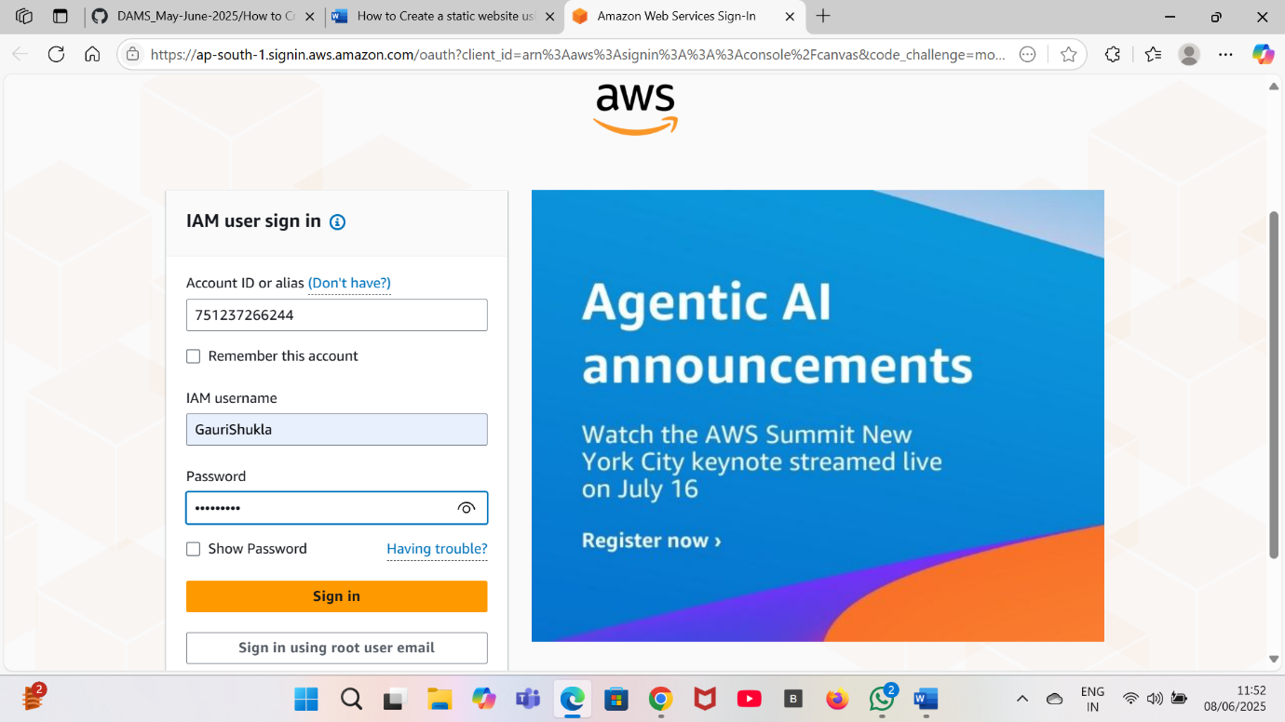

Task 2: Creating Lambda Function

1. Click on the search bar and **enter Lambda** and click on **Lambda.**
2. Click on **Create a Function.**
3. Click on **Author from scratch.**
4. Enter function name.
5. Now click on **create function.**
6. For runtime choose **Python3.13.**
7. Set Architecture to**x86_64**.
8. Now click on **create.**
9. Your first lambda function is created successfully.

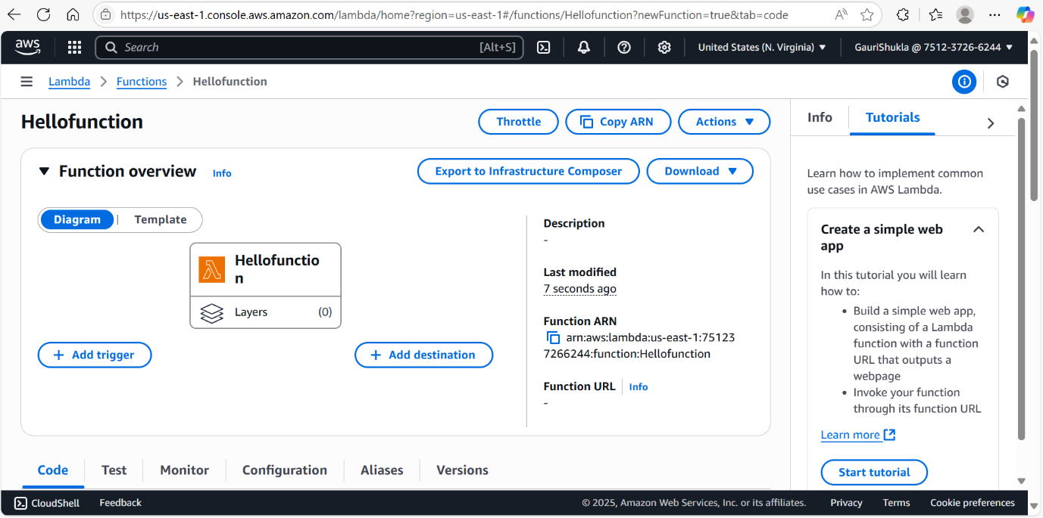

**Task 2:Run the default code**

1. In the lambda function code editor you will be able to see a default code.

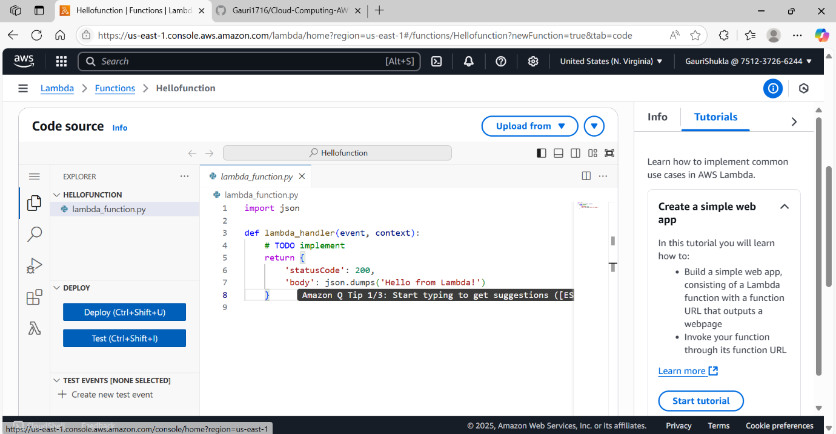

1. Now, **create a test event** and save it.

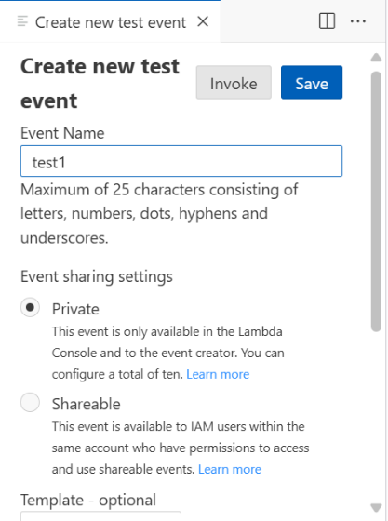

1. Click on test even which you have created and click on **execution**.
2. Now you can see the output “Hello from Lambda!”

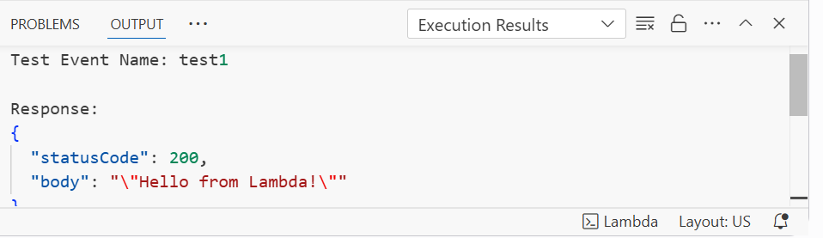

Task 3: Add a Trigger:

1. Go to the **lambda function** which you have created.
2. Now click on **add Trigger.**
3. Now select any services like S3, API GATEWAY etc.
4. In **Intent** , select **create new API gateway.**
5. **API type** :*HTTP API.*
6. **Security**: Select **open**
7. Click on **Add.**
8. Configure the **trigger** and save.
9. Now, go to configuration.

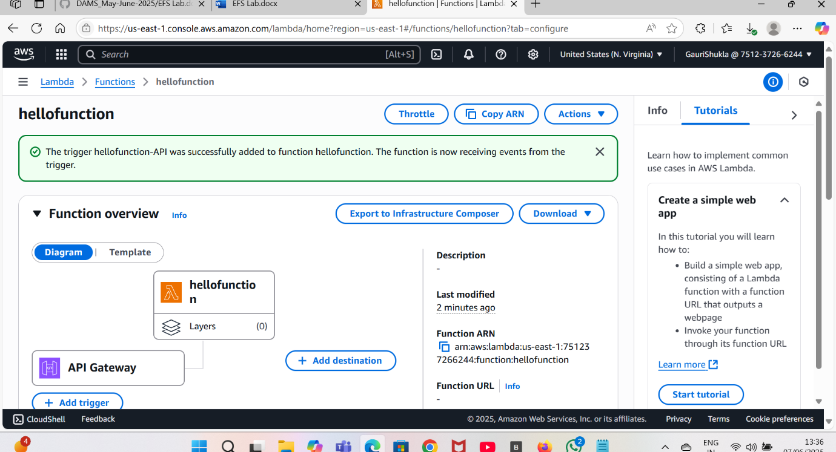

1. Now copy the endpoint of API .

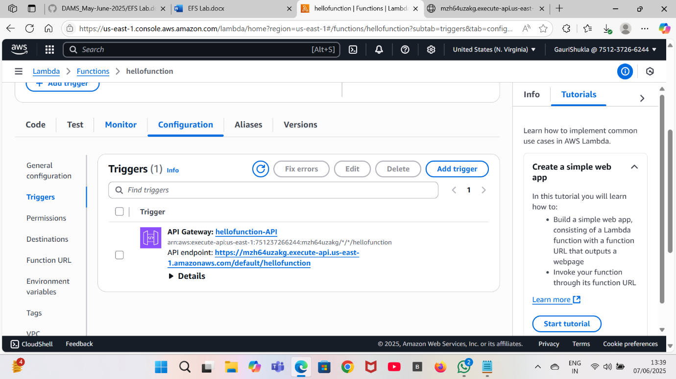

1. Run it on your browser and you will the output.

